**B Tech Project**

**Report**

**Student Name : Sanjan Prakash (EP14BTECH11007)**

**Topic : Visualising the 1-D Schrodinger Equation**

**Objective :** Through this project, I have attempted to visualize and thus simulate the behavior of the wave function of a particle in a box with a finite potential wall. I have done so, using a Python script.

**Introduction :** Since we are concerned with the behavior of the particle within a box, we shall start to describe what we actually mean by a ‘particle in a box’. As long as we are within a one-dimensional space, the quintessential ‘box’ is simply a region of space described by the boundary *a ≤ x ≤ b,* where *a* and *b* are real and finite. Such a region can be described by a potential function *V(x)*, which takes a finite constant value *V0* for all values of *x* except for the ones that are within the boundaries of the box (*a ≤ x ≤ b*). Inside the box, the value of the potential function *V(x)* is zero.

When we say that ‘the particle is within this box’, we mean that the particle does not have sufficient energy to escape the boundaries of this ‘box’. An analogy of this situation in the realm of classical physics could be, a ball in a box bouncing back and forth against both the sides of the box.

Returning to the realm of quantum physics, we cannot treat the behavior of these particles just like any ordinary physical object. We would face uncertainties in its velocity and momentum (*Heisenberg’s Uncertainty Principle*). To cope with this, we attach a transcendental function *ψ(x)* which is space-dependent and use it to find the probability of a particle’s position and momentum at a given time. This function *ψ(x)* is referred to as the ‘wave function’ of the particle. The exact expression for this wave function is obtained by solving the Schrodinger equation :

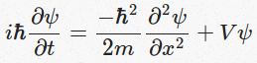

Therefore, given the Schrodinger equation and the potential function, the behavior of the particle under consideration can be described by means of its wave function.

**Project Synopsis :** Being true to the aim of this project, in order to visualize this wave function, the aforementioned Schrodinger equation will have to be numerically solved. In order to do so using a computer, we need to somehow convert this ‘continuous’ problem into a ‘discrete’ problem. I have tried to do so using the split-step Fourier method.

The Fourier transform of the wave function *ψ(x)* is given by the equation :

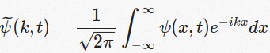

The corresponding Inverse Fourier transform of the wave function *ψ(x)* is given by the equation :

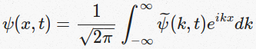

Performing the Fourier transform on both sides of the Schrodinger equation yields a differential equation (Schrodinger equation in the k-space) :

Screenshot from 2016-11-28 06:56:58.png

Now, for discrete time intervals of Δt the Schrodinger equations in the x-space and k-space are solved and are obtained to be :

Screenshot from 2016-11-28 07:08:18.pngand Screenshot from 2016-11-28 07:08:56.png

This will have to be done for each and every time interval, which means there would be repeated computations of the Fourier transform of wave function in the x-space and the Inverse Fourier transform of the wave function in the k-space*.* Here, the need for discretisation is facilitated by the Fast Fourier Transform (FFT). The discrete Fourier transform is :

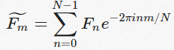

And, its inverse transform is :

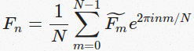

In order to proceed in this manner, certain approximations will have to be made.

Since we are dealing with a particle in a box, its motion would largely be restricted to the region *a ≤ x ≤ b*. Thus, the infinite Fourier integral and its inverse are well-approximated by the finite integral from *a* to *b*. This is equivalent to assuming that the potential *V(x)→∞* at *x* *≤ a* and *x ≥ b*. This integral can further be approximated as a Riemann sum of *N* terms so that we can define *Δx = (b − a)/N*, and *xn = a + nΔx*. Further approximations in the k-space would need us to define *km = k0 + mΔk*, with *Δk = 2π/(NΔx) = 2π/(b - a)*. Then, our approximation becomes :

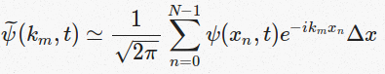

Substituting the expressions for *xn* and km into this approximation and re-arranging terms gives us :

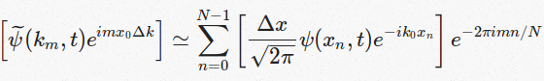, for the Fourier transform, and

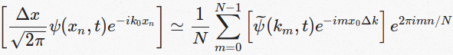 , for the inverse Fourier transform.

Thus, we have obtained the discrete analog of the continuous Fourier transform pair :

C:\Users\USER\Desktop\Project\Capture.PNG

This will help us in solving the differential equation which is the Schrodinger equation.

**Algorithm :** The steps that are carried out are listed below :

1. Choose *a*, *b*, *N* and *k0* sufficient to represent the initial state of the wave function *ψ(x)*

2. Then, *Δx = (b − a)/N* and *Δk = 2π/(b - a)*

3. Define, *xn = a + nΔx* and *km = k0 + mΔk*

4. Discretise the wave function in the x-space for every *n* as :

C:\Users\USER\Desktop\Project\Capture2.PNG

Discretise the wave function in the k-space for every m as :

C:\Users\USER\Desktop\Project\Capture3.PNG

To support this, the potential function will also have to be discretised as *Vn = V(xn)*

Steps 5 to 9 indicate the progress of the system by a time-step *Δt.*

5. Compute a half-step in the x-space as follows :

C:\Users\USER\Desktop\Project\Capture4.PNG

6. Calculate the wave function in the k-space from the wave function in the x-space using the Fast Fourier Transform.

7. Compute a full-step in the k-space as follows :

C:\Users\USER\Desktop\Project\Capture5.PNG

8. Calculate the wave function in the x-space from the wave function in the k-space using the Inverse Fast Fourier Transform.

9. Compute a second half-step in the x-space as follows :

C:\Users\USER\Desktop\Project\Capture6.PNG

Steps 5 to 9 are repeated for all the following time intervals of *Δt* too, until the desired time is reached.

**Result :** The following pictures show the particle approaching the potential barrier and leaving/breaching it too :

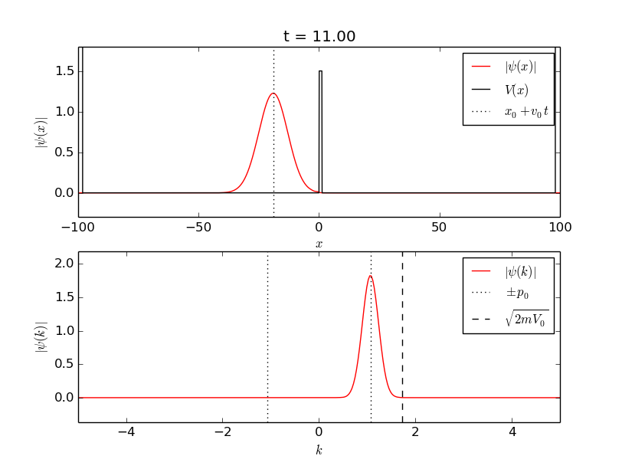

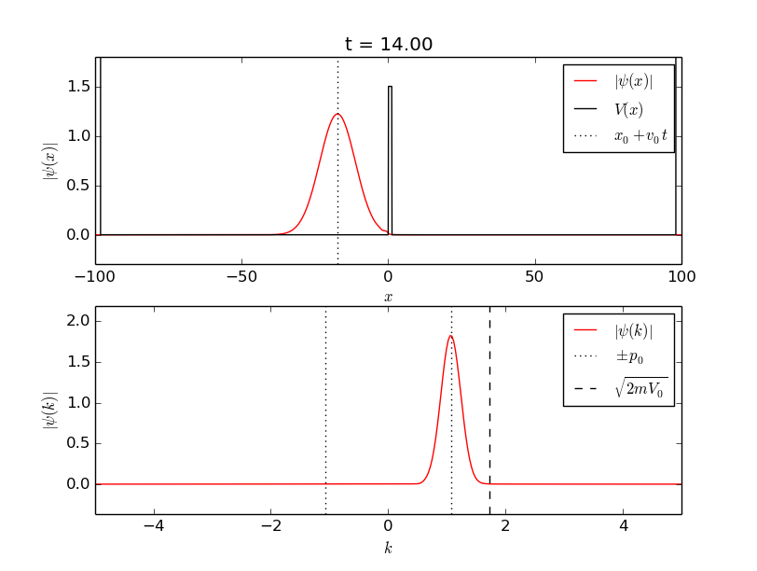

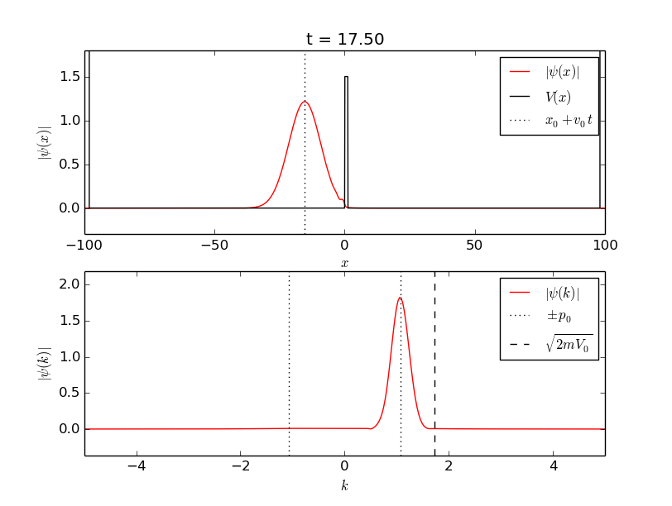

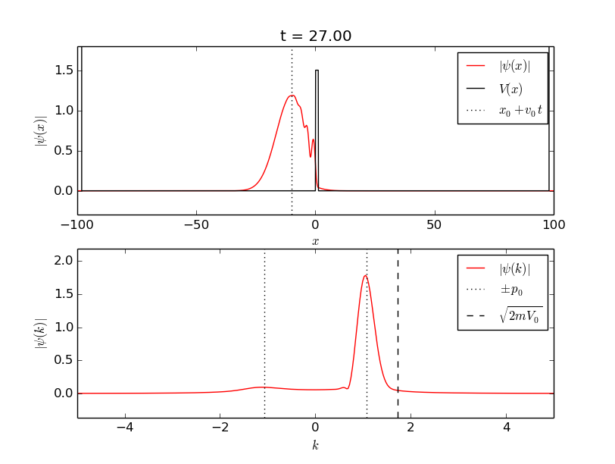

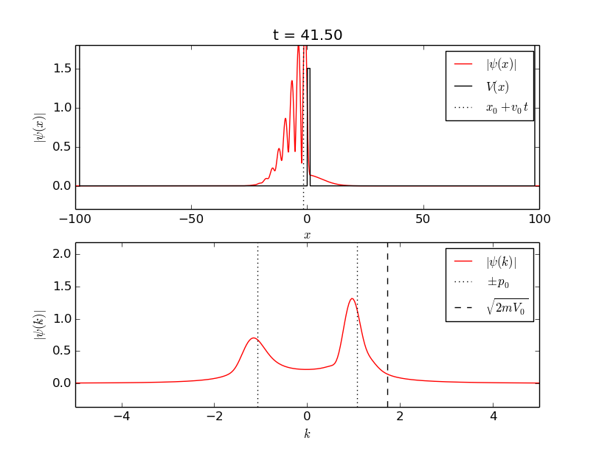

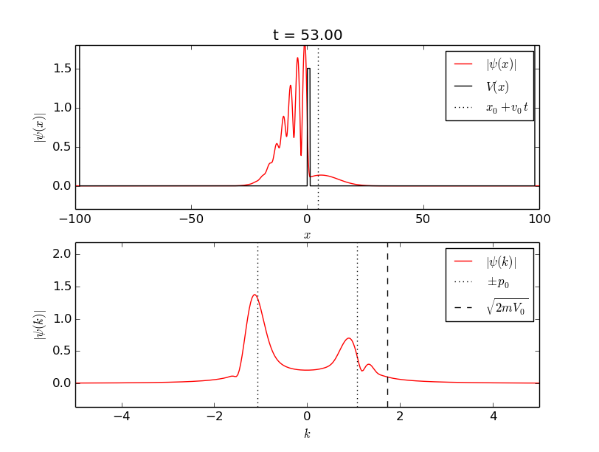

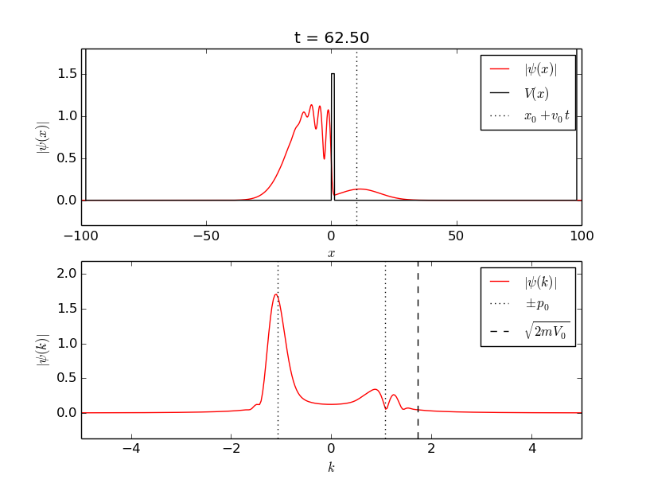

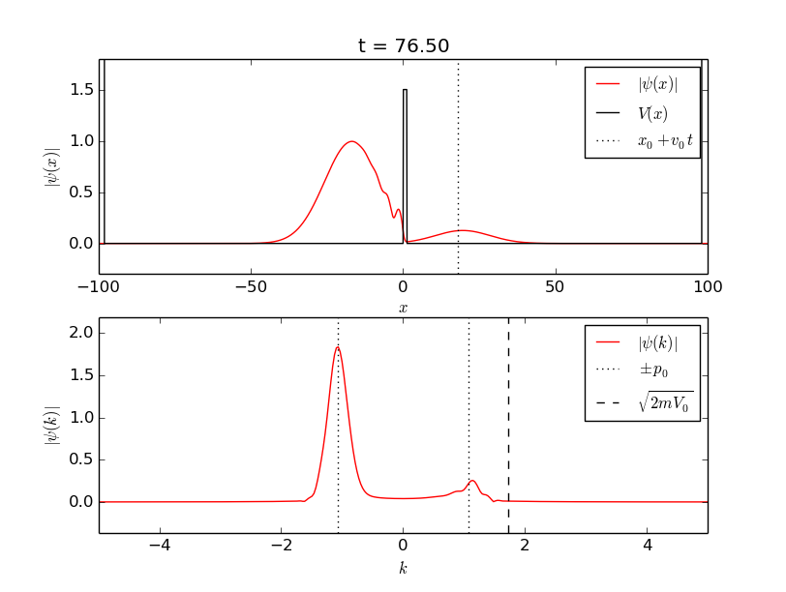

The solid line in the above panel in each of these images represents the potential barrier. The barrier is high enough for a classical particle to not penetrate it. However, a quantum particle can pass through this barrier, leading to a non-zero probability of finding the particle beyond the barrier as seen in these images. This is known as the ‘quantum tunneling effect’.

The following images show the evolution of the system with time :

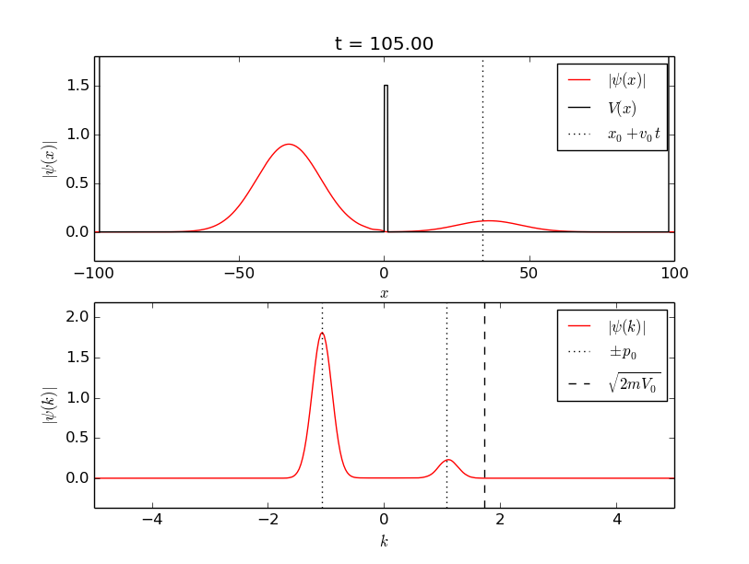

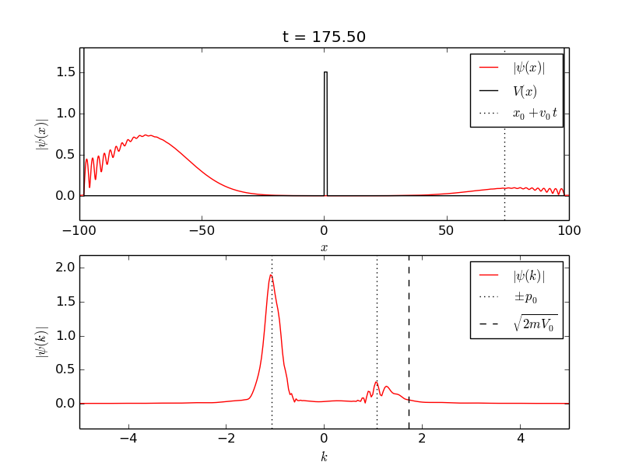

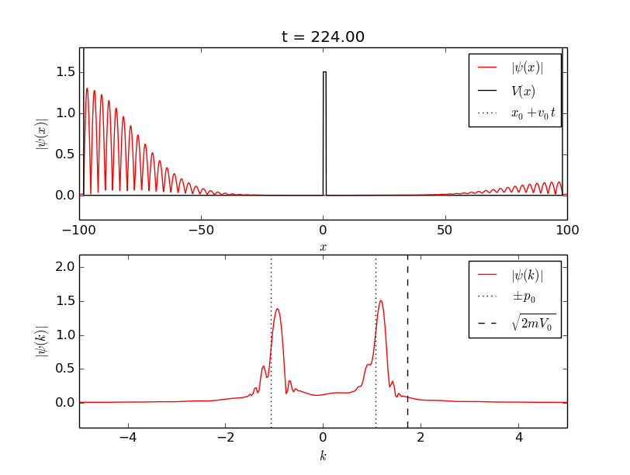

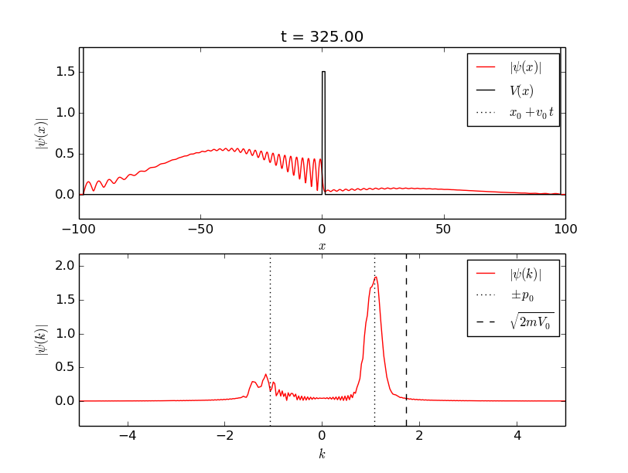

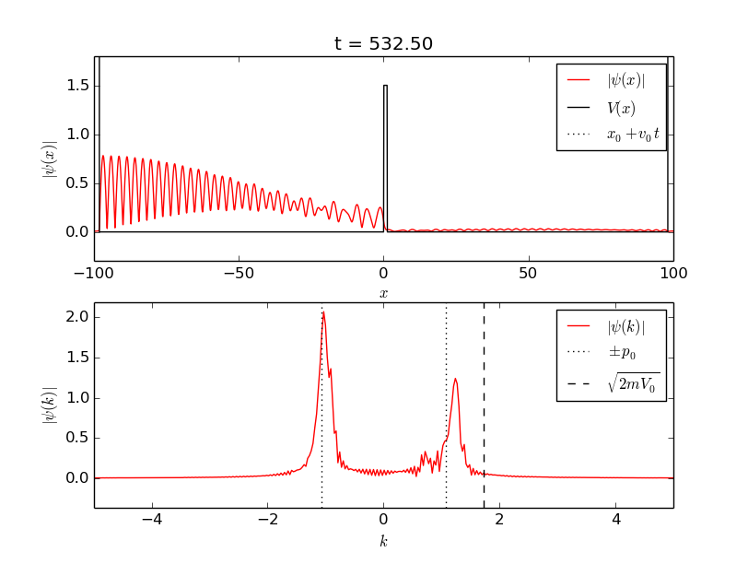

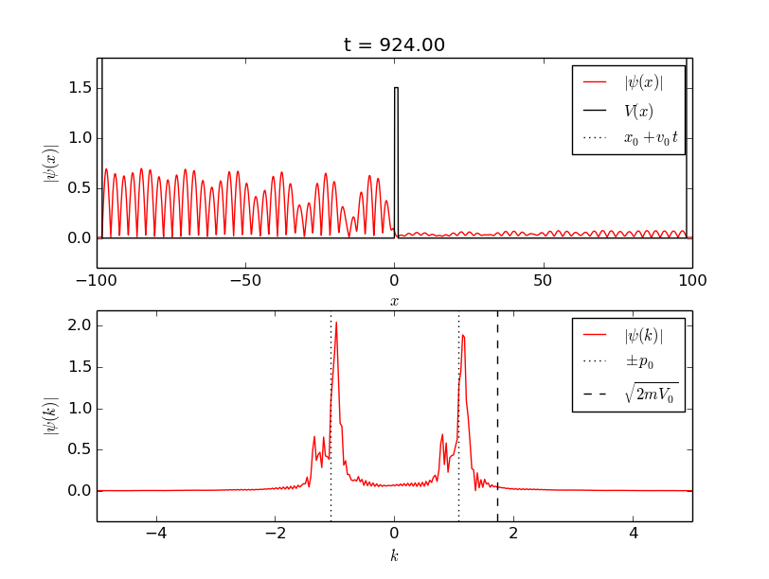

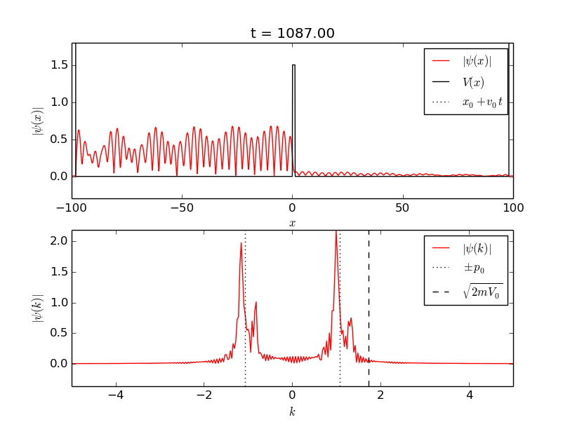

The particle ‘most probably’ resides inside the ‘box’ formed by the potential barrier. As time goes by, the particle collides with the walls of this ‘box’ and is set in a to and fro motion from wall to wall. The two peaks in the bottom panel correspond to the average momentum (*k* happens to be the momentum of the particle) of the particle, in either direction (hence the two different signs).

**Conclusion :** Thus, with my understanding of the Schrodinger equation and the split-step Fourier method, I was able to visualize and simulate the behaviour of the one-dimensional wave function of a particle in a box with a potential barrier using a Python code.

**References :**

* *Introduction to Quantum Mechanics* by David Griffiths
* Python 2.7 Documentation (references for the code)
* *Numerical Methods for Physics* by Alejandro Garcia
* Wikipedia